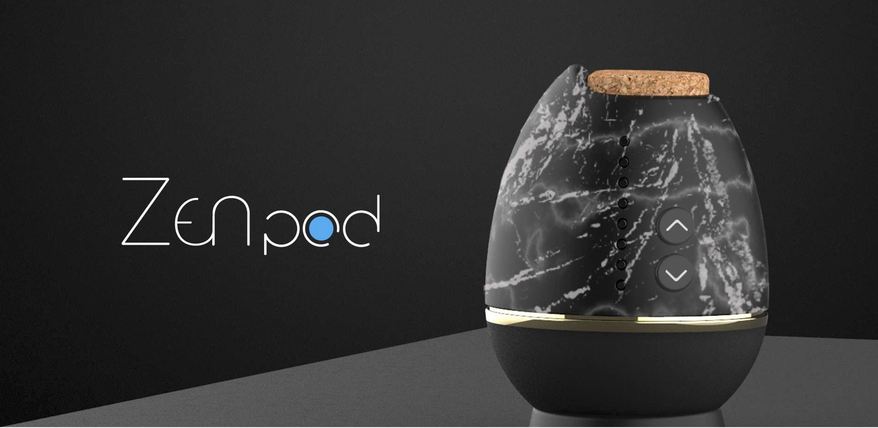

CCS Project Designer: Tomoya Ono

ECE team: Brikena Dulaj

Michael Muller

Sumit Raut

Pavan Singh

e-mails: [brikenadulaj@oakland.edu](mailto:brikenadulaj@oakland.edu) , [mwmuller@oakland.edu](mailto:mwmuller@oakland.edu) , [sumitraut@oakland.edu](mailto:sumitraut@oakland.edu), [pavansingh@oakland.edu](mailto:pavansingh@oakland.edu)

Introduction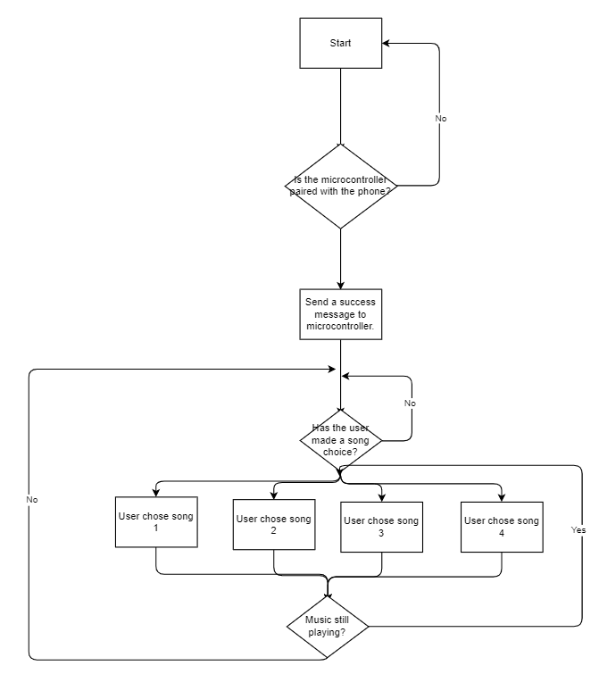

The Zenpod is a meditation assistance device designed by Tomoya Ono. The intent of this device is to promote proper and improved meditation sessions through the use of haptic, aromatics, and acoustic stimulation. The Zenpod is designed to ground the user and provide physical feedback regarding breathing patterns. We chose to work on the Zenpod to explore the need for advanced, daily use products for the average consumer in areas that are not commonly affected by the growing technological field. As software and hardware become more complex, accessible, and affordable, we wanted to apply the skills we’ve learned to bring some of these improvements to a less mainstream outlet.

To better understand the feedback provided by the Zenpod, we will cover each feature’s utility, necessity, and implementation. This will be followed by a section outlining the potential improvements to each feature.

**Acoustics**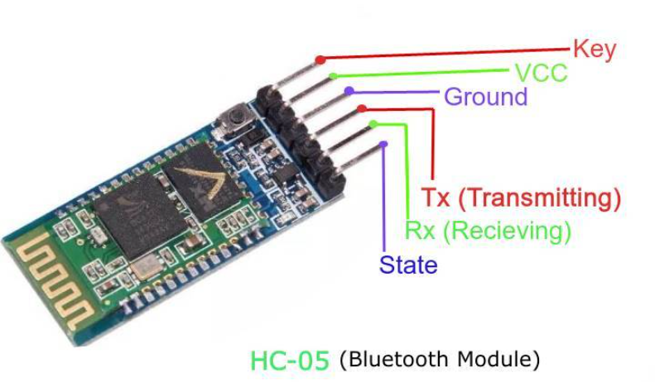

The goal of this part of the project is to allow the user to pair their phone with the zenpod and play music through it. There are many Bluetooth modules available but for this project, we have picked the HC-5 to enable a flowy connection with the Freedom board. So far the test has provided one challenge that’s the available app for the HC-5 module is able to configure only android devices, meaning that for the user to be able to use any device another app need to be created. However, for the purposes of this project we will try to use what’s available as a start. Another component we have planned to use on this project is a an SD card module and an SD card. In order to play music we need to read from a memory card such as an SD card. 4 different music choices were hardcoded into an SD card and used to play the music in the zenpod. The logic of this design is as described above in the flow chart. The SD module will be used through an SPI communication which in turn will be stored in a DMA memory. The DMA will therefore convert the recorded waveform into a DAC form.

# Haptic Feedback: Breathing

The breathing vibrations in the Zenpod are controlled by a small servo motor. The freedom board controls a transistor that will periodically open and close the circuit allowing the servo motor to vibrate. Using the system clock on the KL25Z, we can keep track of the inhale and exhale times for the motor, as well as how long a typical meditation time lasts. The system clock is set to run at 2 Mhz and generates an interrupt every 1 second, which we use to check and update any state machines and peripherals. When meditation begins, we allow the meditation time to begin decreasing and the breathing state machine (Figure 2) starts functioning. Different breathing patterns can be selected either via a bluetooth web app or physical buttons on the device. Currently, only three breathing settings are encoded by default, each denoted by a green, yellow, and red led respectively ordered from shortest to longest breathing pattern. So long as the pod is in meditation mode, the servo motor will continue to vibrate. At any time, the breathing pattern may be changed and/or meditation paused via the On/Off button.

To maintain responsiveness, the SysTick timer will have priority and call the other state machines for updates. When a button is pressed, we wait until the next flag read occurs before acting on the request. This should be unnoticeable to the user, and still allows for more important features to execute.

A UART communication is used between two bluetooth devices to send breathing related information to the Zenpod. The meditation time can range from 20 to 120 minutes. When an interval is set by the user, it is rounded up to the nearest ‘5’. This is to allow for Meditation time, On/Off state, and breathing pattern to be transferred in a single byte of data.

Zenpod Interface

The main goal of this part is that users should be able to increment or decrement the meditation time by pressing + or - Switch respectively. Hardware required for this part is 4 LEDs which will increment the time selected by the user, KL25Z Freedom Board, 2 SPST Switches, 4 220 ohm resistors.

So assuming that meditation time is 0mins, every time users press (+) button, meditation time increases by 5 minutes for every press. If it's at 20 minutes it wont increase further.. If users press the (-) button then meditation time will decrease by 5 minutes and if it's at 0 minutes it won't decrease further.

Finally the meditation time is displayed by LEDs . There are 4 LEDs to show meditation time and each LED counts as 5 minutes.

C Code:

**Aromatics**

The heating pad is turned on automatically as soon as the meditation is started by the user. The heater pad is controlled by the PWM signal from the controller. The heating PWM duty cycle is selected automatically based on the breathing inhale and exhale time by the user. The shorter the breathing time the less the heating required, this is based on the assumption that more heating/oil diffusion is required when the breathing is intense from the user during the meditation. There are three different levels of the PWM duty cycle based on three different breathing patterns. This heating mechanism is selected to make the things easier for the meditation. As the user does not have to specifically set the heating input for the controller.

As a fail safe mechanism, the inhale/exhale timer is constantly checked before setting the PWM duty cycle. In case of an undetermined state the heating is set to lowest PWM duty cycle which is set to 20%. Further, in case of losing the inhale/exhale setting after starting the program the heater PWM duty cycle is reset to lowest value. To be at the safer side the highest PWM duty cycle is selected to be 80%. It could be calibrated to higher/lower value after the testing is completed.

Conclusion

Anyone can watch youtube videos, listen to an instructor, or throw on some music with your phone and close your eyes, but the Zenpod is an all-in-one product to help detach yourself from a screen and focus on concentration. With some simple software and affordable hardware, we were able to achieve most of the invisionsed features of the Zenpod by Tomoya. This version, however, would be considered more of a DIY Zenpod, but with the proper internal design this software could easily pilot a polished Pod.

One of the major improvements to our Zenpod would be the addition of an internal charger and improved hardware. A dedicated internal battery would allow for a much more powerful and controlled ‘breathing’ servo motor. While not covered in our project, a professionally done Mobile App would take this to the next level. Giving the user the ability to customize even more aspects of the Zenpod. Personally defined dynamic breathing patterns could be created and even shared among users. Adding a USB port could be used to download pre-defined meditation sessions with varying settings as well. The inclusion of a dedicated SD card would allow for songs to be saved to the device for later listens as well.

Overall, we believe Zenpod has the potential to redefinem, and even bring luxury and personalization, to self-meditation. We look forward to seeing what the Zenpod has in store for the future!

*Flow charts and code provided in separate files due to size.*